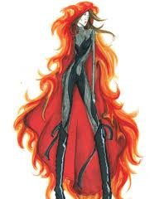
Create your own costume
Task
Work with your partner to create a costume for a tribute to wear to the opening ceremony. This is for display work.
Step 1
Decide which district your tribute will be from. Remember that the costume has to somehow represent the speciality of that district. (NB: We’re not told the speciality of all of the districts)
1. Luxury Items
2. Unknown
3. Factories
4. Fishing, anything sea-related.
5. Unknown
6. Unknown
7. Trees, wood
8. Textiles (clothing)
9. Electricity
10. Raises livestock & cattle for eating
11. Agriculture
12. Coal Mining
Step 2
Decide which characteristics/qualities you want to demonstrate that your tribute possesses. Remember that the purpose of the ceremony is to win sponsors and intimidate other tributes. How will you symbolise these qualities?
Step 3
Paint/ Draw your costume design and then label it to explain why you have made those decisions.

